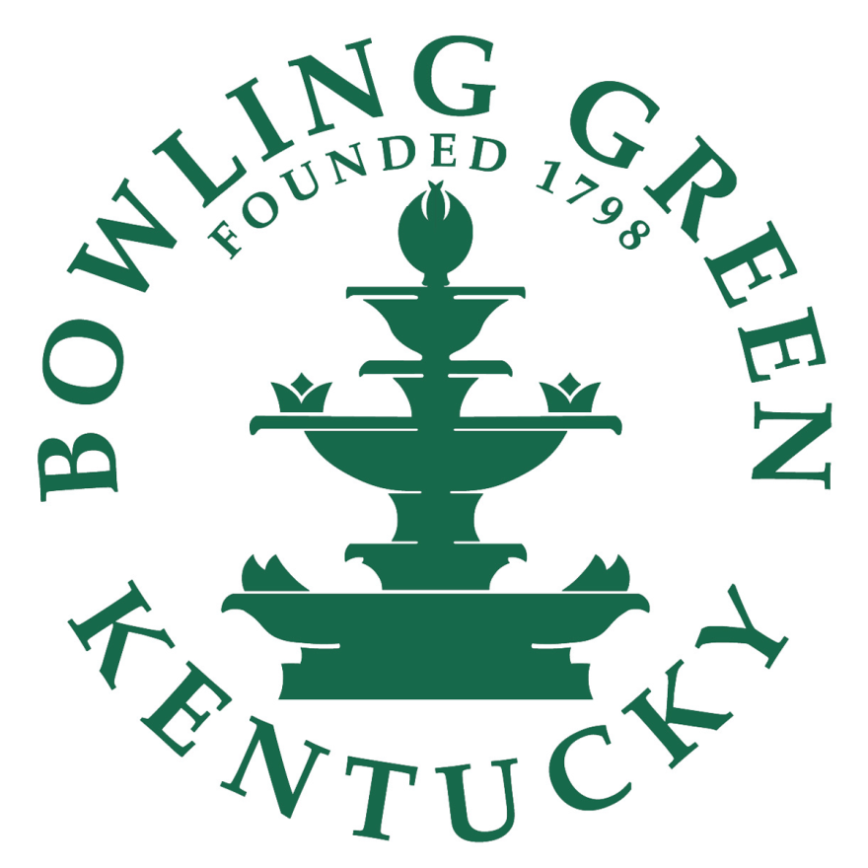

**City of Bowling Green**

Internal Auditor’s Office

Fiscal Year 2021/2022

Annual Audit Plan

Deborah Jenkins, CIA, CFE, CGAP, CICA

07/02/21

***Introduction***

Enclosed is the Fiscal Year 2021/2022 Audit Plan for the Internal Auditor’s Office. Professional internal audit standards, as well as the Internal Auditor’s Office Charter, requires the preparation and presentation of this type of plan to the Audit Committee. The process evolves periodically and this audit plan attempts to balance between the large scope audits of the past and the more recent narrowed scope audits. I feel this audit plan is a more appropriate balance of issuing a solid amount of reports while also being scoped appropriately to ensure they are providing value to management.

***Audit Prioritization and Selection***

A risk assessment was performed to identify and prioritize audits posing the greatest potential for risk and liability to the City. This process provides a tool to assign priority for the purpose of reducing the risk and liability exposure through observations, testing, analysis and recommendations. In developing the risk assessment model and audit plan, risk is defined as the potential for loss to a division due to error, fraud, inefficiency, failure to comply with statutory requirements or actions which may have a negative effect on the City.

A systematic risk assessment approach was performed. This approach separates risk into individual *risk factors*, which were assessed individually, then combined into an overall score reflecting a Division’s risk potential. For each of the individual risk factors, the Internal Auditor’s Office evaluated the associated risk and ranked them in one of several risk levels. This process attempts to account for a relative measure of importance between each of the risk factors and the resulting impact on the overall risk score for each division by weighting each individual risk factor. A “weighting” factor was derived by performing a comparison of each specific risk factor, with all the other risk factors on a “more important than” basis. The result of this analysis is summarized in Attachment #2.

Risk assessment meetings were conducted with senior managers to discuss risk in their respective departments as well as any upcoming changes or challenges in their area of responsibility. Meetings included:

City Manager Department Jeff Meisel - City Manager

Human Resources Department Erin Hulsey - Director

Public Works Department Greg Meredith - Director

Legal Department Hillary Hightower - City Attorney

Neighborhood & Community Services Brent Childers - Director

Fire Department Jim Morrow - Interim Fire Chief

Rob Gilliam - Deputy Chief

Shannon Pardue - Deputy Chief

Finance Department Katie Schaller-Ward - Assistant City Manager/CFO

Information Technology Department Lynn Hartley - Chief Information Officer

Parks and Recreation Department Brent Belcher - Director

Police Department Michael Delaney - Police Chief

***The Fiscal Year 2021/2022 Audit Plan***

The recommended Audit Plan for Fiscal Year 2021/2022 considers available audit hours, found in Attachment #1 and identifies the potential audit areas listed in the chart below.

City Security Cameras Audit

Software Management and Support Audit

MainTrak Park Maintenance Work Order Audit

Building and Inspection Division Audit Follow-Up

Fitness Center Audit Follow-Up

911 Center Funding Audit Follow-Up

The Fiscal Year 2021/2022 Audit Plan includes time to conduct unannounced cash counts, City facility site visits, and random spot checks and administer the Employee Ethics Hotline, while being responsive to special requests and advisory needs of management. There is continued concern about audit coverage as a one-person audit shop, but I will continue to search for ways to add greater value to the City based on the resources available.

On May 6, 2021, I was elected as an At-Large board member to the Association of Local Government Auditors (ALGA) and will be serving a two year term. ALGA’s membership includes auditors from cities, counties, utility districts, transit agencies, tribal governments and more. It is a local government auditor organization that supports auditors throughout the US and Canada and I am thrilled to be given the opportunity to give back to this organization and support existing and future local government auditors.





